



FAST School of Computing
National University of Computer and Emerging Sciences

Course: Software Engineering

Project Title: Senti Mind — Mental Health Journaling & Clinical NLP Analysis Platform

Members:
Abdullah Mushtaq ............ 23L-0892

Deliverable No: 2

Date of Submission: April 11, 2026

1. Introduction
SentiMind is a full-stack mental health web application that combines personal journaling with a real-time, six-layer clinical NLP analysis pipeline. Users type their thoughts freely; within seconds, the system analyses emotional spectrum, clinical conditions, semantic context, and crisis risk — then delivers a compassionate AI-generated insight alongside evidence-based coping strategies.
The application is architected as a decoupled system: a React/Vite frontend styled with TailwindCSS (Sage colour palette, glassmorphism), a Python FastAPI backend hosting the full NLP pipeline, and an OpenRouter-connected LLM integration for the compassionate response layer. User authentication, data persistence, and longitudinal tracking are powered by Supabase (PostgreSQL with JWT auth).
The six pipeline layers are:
- Layer 0 — Preprocessor: Noise cleaning and emoji-to-text translation before any model sees the input.
- Layer 1 — Emotion Detection: DistilRoBERTa (Hugging Face) extracts intensities for 7 core emotions (joy, sadness, anger, fear, disgust, surprise, neutral).
- Layer 2 — Clinical Classifier: LinearSVC (trained via GridSearchCV on Kaggle mental health data) categorises text into 7 states: Anxiety, Depression, Normal, Bipolar, Personality Disorder, Stress, Suicidal.
- Layer 3 — Context Mapper (NER): spaCy Named Entity Recognition extracts subjects and semantic context clues.
- Layer 4 — Risk Logic Engine: Weighted scoring of suicidal confidence, distress keywords, and fearful/sad emotion intensities to output Low / Medium / High / Critical risk tiers.
- Layer 5 — Compassionate AI: LLM (via OpenRouter) injected with the clinical context to generate an empathetic insight and bulleted coping strategies.
Sprint 1 delivered the complete working pipeline, the full React frontend including the EmotionChart and InsightModal components, and cloud deployment on Vercel (frontend) and Render (backend).
Sprint 2 (Current Sprint) extends the platform with user authentication, data persistence, longitudinal mood tracking, clinical screening tools, and wellness utilities — transforming the analysis tool into a comprehensive mental health journaling platform.

Sprint 2 New Features Overview
• User Authentication & Authorization: JWT-based authentication using Supabase Auth with protected routes and session management.
• Journal Entry Persistence: All journal entries are automatically saved to Supabase PostgreSQL database with user association.
• History & Retrieval: Users can view, retrieve, and delete their past journal entries with full analysis history.
• Mood Heatmap: 30-day visual calendar heatmap showing emotional state patterns with color-coded clinical categories.
• Gratitude Vault: Dedicated space for users to save and reflect on positive moments and gratitude entries.
• Clinical Screener (GAD-2/PHQ-2): Standardized clinical assessment tools for anxiety and depression screening.
• Wellness Tools: Crisis grounding utilities including Box Breathing and 5-4-3-2-1 sensory grounding techniques.
• Enhanced Crisis UI: Improved crisis alert banners with direct links to wellness tools for high-risk situations.
• PDF Export: Generate and download PDF reports of journal entries and analysis results.

2. User Stories:

US-02 | UI/UX Improvement

As a user, I want a premium, clinical-grade interface with intuitive navigation and soothing aesthetics, so that I feel secure and comfortable while tracking my mental health data.

Sub-Stories:

- Sub-Story 1.1: Implement a universal glassmorphic design system and cohesive modern color palette.
- Sub-Story 1.2: Replace generic system emojis with custom medical/health vector iconography across all modules.
- Sub-Story 1.3: Redesign the Dashboard, History, and Wellness Tools pages for a more engaging, trustworthy feel.
- Sub-Story 1.4: Add tactile micro-animations to interactive elements (buttons, cards, inputs) to enhance user responsiveness.
- Sub-Story 1.5: Optimize global layout components to ensure fluid mobile responsiveness and cross-device consistency.
- Acceptance Criteria:
  - All core pages reflect the new glassmorphic visual style without breaking existing content or functionality.
  - Custom vector icons render successfully and accurately depict their related modules instead of default text emojis.
  - Hover interactions, clicks, and page transitions trigger smooth, standardized micro-animations.
  - The application layout adapts seamlessly and maintains visual excellence across varying mobile, tablet, and desktop viewports.

US-02 | Create Login/Register Module
Priority: Critical | Estimated Hours: 12
As a user, I want to create an account and log in securely, so that my journal entries and mental health data remain private and accessible only to me.
Sub-Stories:
- Sub-Story 2.1: Implement Supabase Auth integration with JWT token management.
- Sub-Story 2.2: Create LoginPage with email/password authentication and form validation.
- Sub-Story 2.3: Create RegisterPage for new user account creation.
- Sub-Story 2.4: Implement ProtectedRoute component to restrict dashboard access to authenticated users.
- Sub-Story 2.5: Build AuthContext for global session state management across the application.
- Acceptance Criteria:
- Users can register with email and password.
- Users can log in and receive a JWT session token.
- Unauthenticated users are redirected to /login when accessing protected routes.
- Authenticated users see their session persisted across page refreshes.

US-03 | Create HeatMap & History Module
Priority: High | Estimated Hours: 10
As a user, I want my journal entries to be saved automatically after analysis, so that I can review my mental health journey and track patterns over time.
Sub-Stories:
- Sub-Story 3.1: Create journal.py API endpoints for CRUD operations (Create, Read, Delete).
- Sub-Story 3.2: Implement auth_middleware to validate JWT tokens on API requests.
- Sub-Story 3.3: Auto-save journal entries to Supabase after NLP analysis completes.
- Sub-Story 3.4: Build HistoryPage to list all previous entries with metadata (date, category, risk level).
- Sub-Story 3.5: Build MoodHeatmapPage with 30-day calendar grid visualization.
- Acceptance Criteria:
- Each analyzed entry is automatically persisted to the database with user_id association.
- Users can view a chronological list of all their past entries.
- Each history item displays the clinical category and risk level at a glance.
- Users can delete entries permanently from their history.

US-04 | Gratitude Vault for Positive Reflection
Priority: Medium | Estimated Hours: 8
As a user, I want to save positive moments and entries marked as "Normal" mood to a dedicated Gratitude Jar, so that I can revisit uplifting memories during difficult times.
Sub-Stories:
- Sub-Story 4.1: Add "Add to Jar" button for entries with Normal clinical category.
- Sub-Story 4.2: Create gratitude_snippets table in Supabase for isolated storage.
- Sub-Story 4.3: Build GratitudeJarPage with card-based layout of saved snippets.
- Sub-Story 4.4: Implement delete functionality for gratitude entries.
- Acceptance Criteria:
- Users can save any "Normal" categorized entry to the Gratitude Jar.
- The Gratitude Vault displays entries in a visually distinct, positive-themed card layout.
- Each gratitude entry shows the date it was saved.
- Users can remove entries from the Gratitude Jar without affecting main history.

US-5 | Clinical Screener (GAD-2 & PHQ-2)
Priority: High | Estimated Hours: 12
As a user, I want to complete standardized clinical assessments for anxiety and depression, so that I can receive objective screening scores to share with healthcare providers.
Sub-Stories:
- Sub-Story 5.1: Research and implement GAD-2 (Generalized Anxiety Disorder) 2-question screener.
- Sub-Story 5.2: Research and implement PHQ-2 (Patient Health Questionnaire) 2-question screener.
- Sub-Story 5.3: Create screener.py API endpoint to calculate and interpret scores.
- Sub-Story 5.4: Build multi-step ScreenerPage with progress indicators (50%, 100%).
- Sub-Story 5.5: Display results with interpretation (e.g., "Further evaluation recommended" for scores ≥3).
- Acceptance Criteria:
- Users can complete both GAD-2 and PHQ-2 questionnaires in a guided flow.
- Scores are calculated correctly (0-6 scale for each instrument).
- Scores ≥3 trigger a clinical attention warning with recommendation to consult a provider.
- Results are presented in a clean, medical-grade formatted display.

US-6 | Wellness Toolkit:
Priority: High | Estimated Hours: 8
As a user experiencing distress, I want access to immediate grounding techniques, so that I can self-regulate during moments of anxiety or crisis.
Sub-Stories:
- Sub-Story 6.1: Build WellnessToolsPage with guided Box Breathing exercise (4-4-4-4 rhythm).
- Sub-Story 6.2: Implement 5-4-3-2-1 sensory grounding technique guide.
- Sub-Story 6.3: Create CrisisAlertBanner with direct links to wellness tools when Critical risk detected.
- Sub-Story 6.4: Add quick-access grounding links in the Journal page for high-risk entries.
- Acceptance Criteria:
- Box Breathing tool provides visual/textual guidance for 4-second inhale/hold/exhale/hold cycles.
- 5-4-3-2-1 tool guides users through sensory grounding (sight, touch, hearing, smell, taste).
- Critical risk entries automatically display wellness tool links alongside crisis alerts.
- All wellness tools are accessible without authentication barrier during active sessions.

4. Design:

Architecture Diagram:
- We used Hybrid Architecture
- Server-Client Architecture: Multiple users connect to centralized FastAPI backend with stateless JWT authentication.
- Microservices Pattern: Hugging Face emotion model and OpenRouter LLM are external service integrations.
- Repository Pattern: Supabase PostgreSQL database with row-level security (RLS) for user data isolation.

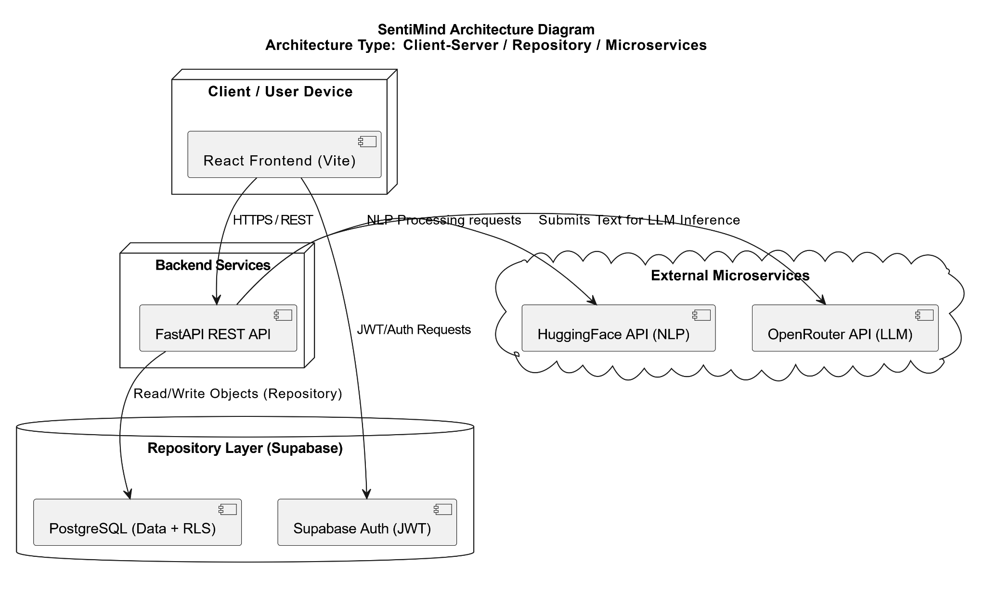

Component Diagram:

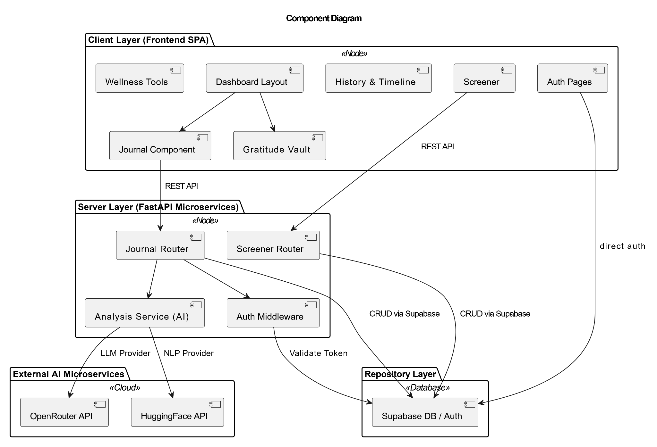

DFD Diagram:
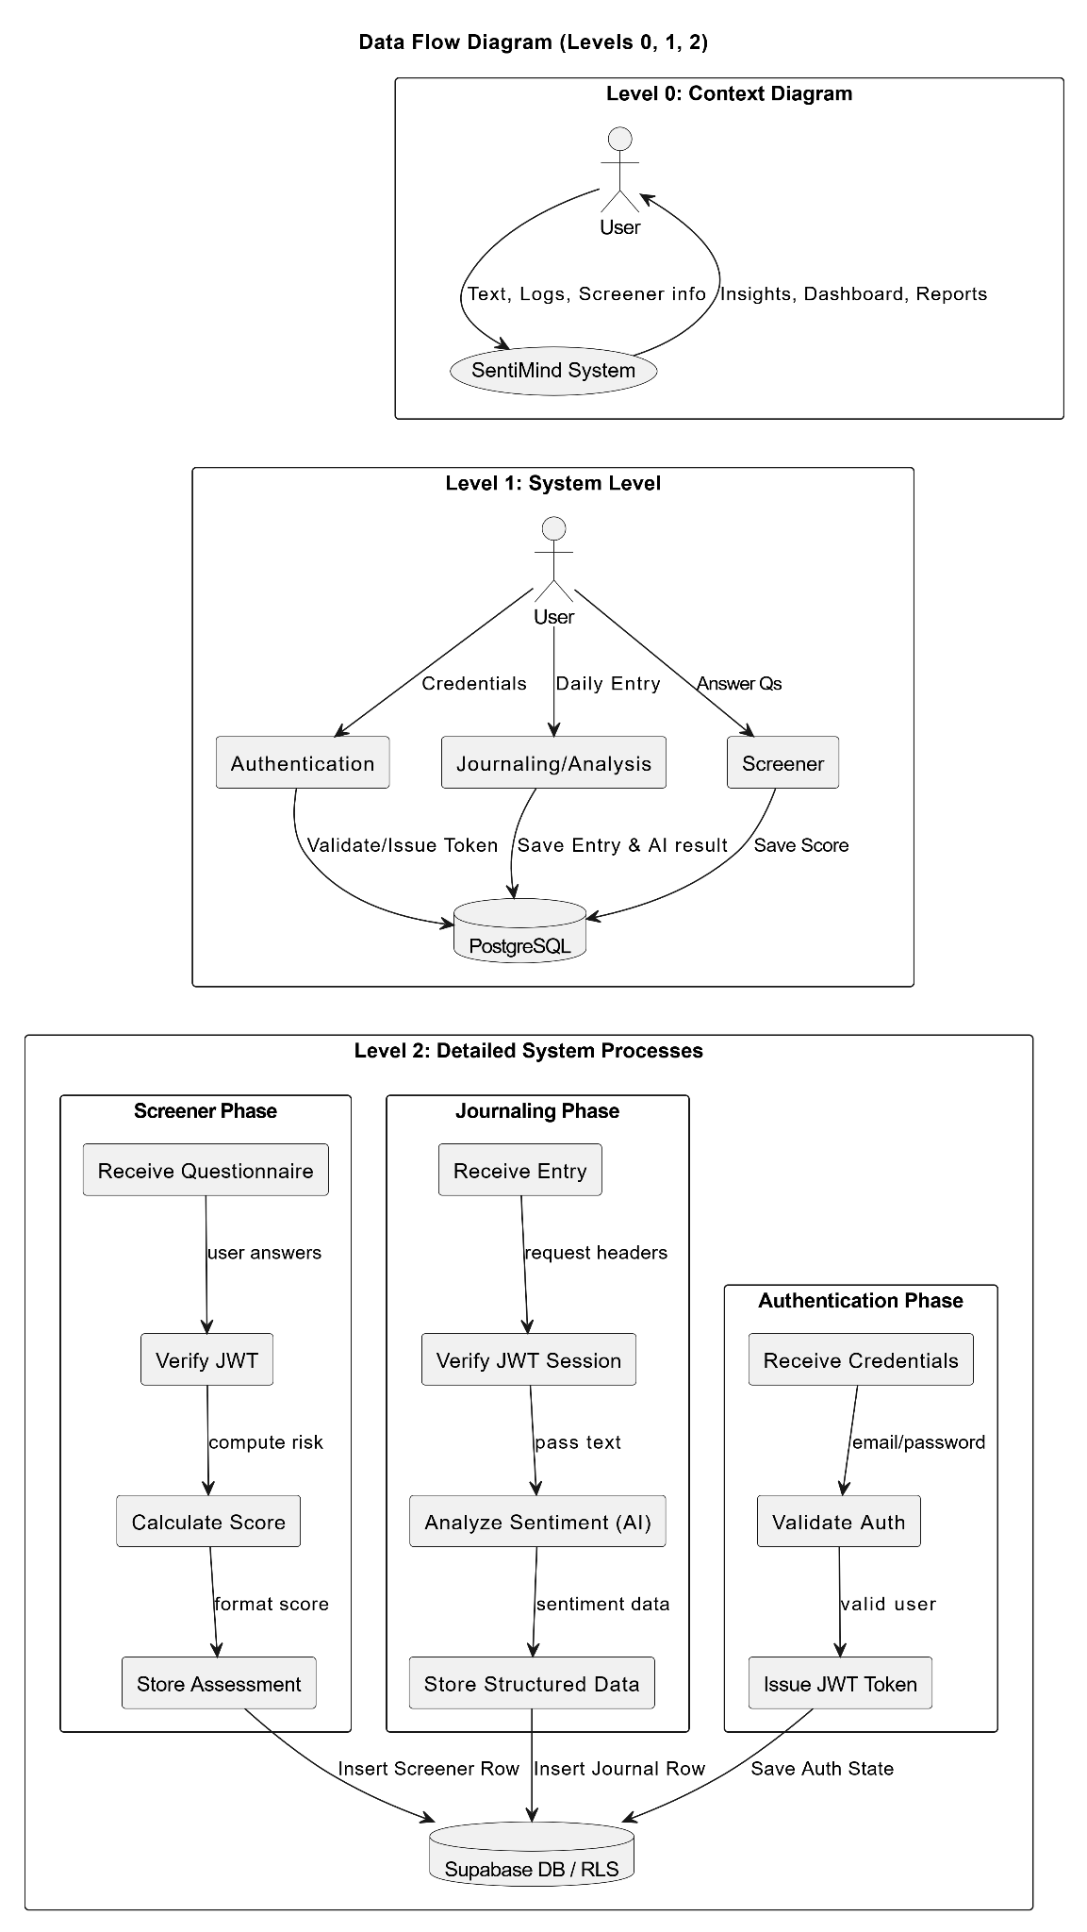

Activity Diagram:

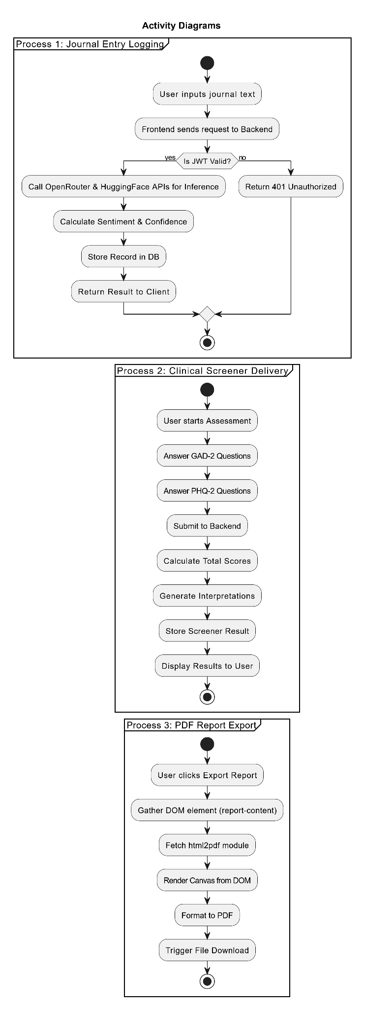

UseCase Diagram:

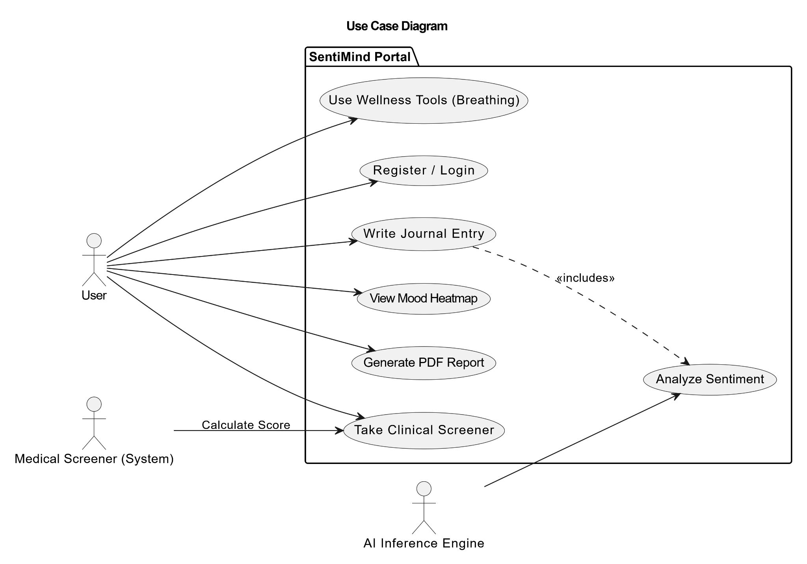

Sequence Diagram:

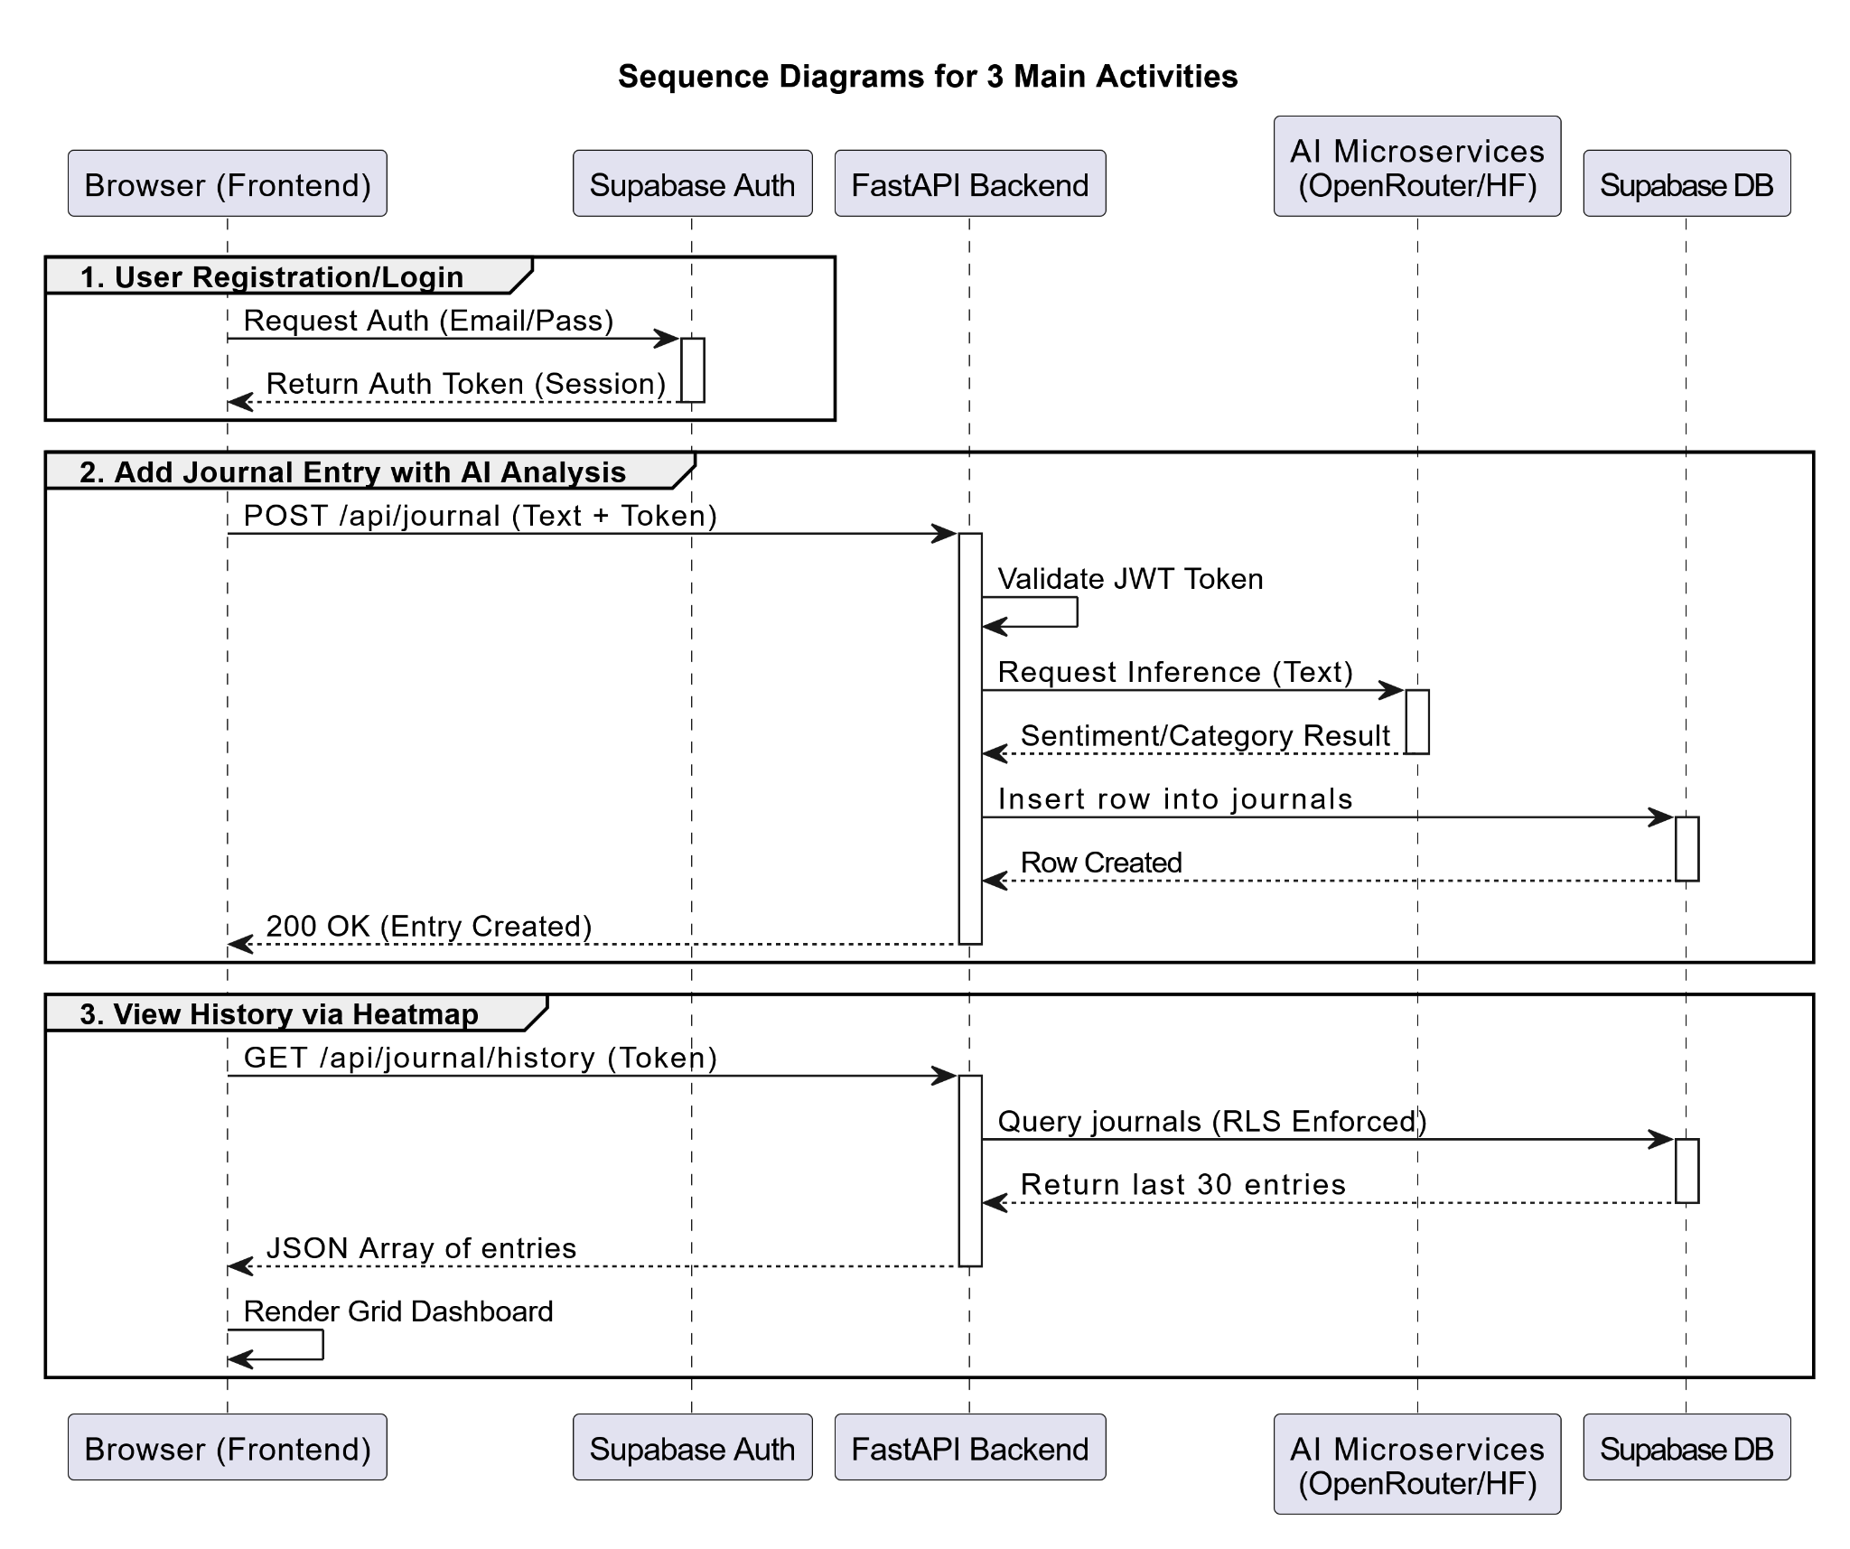

Class Diagram:

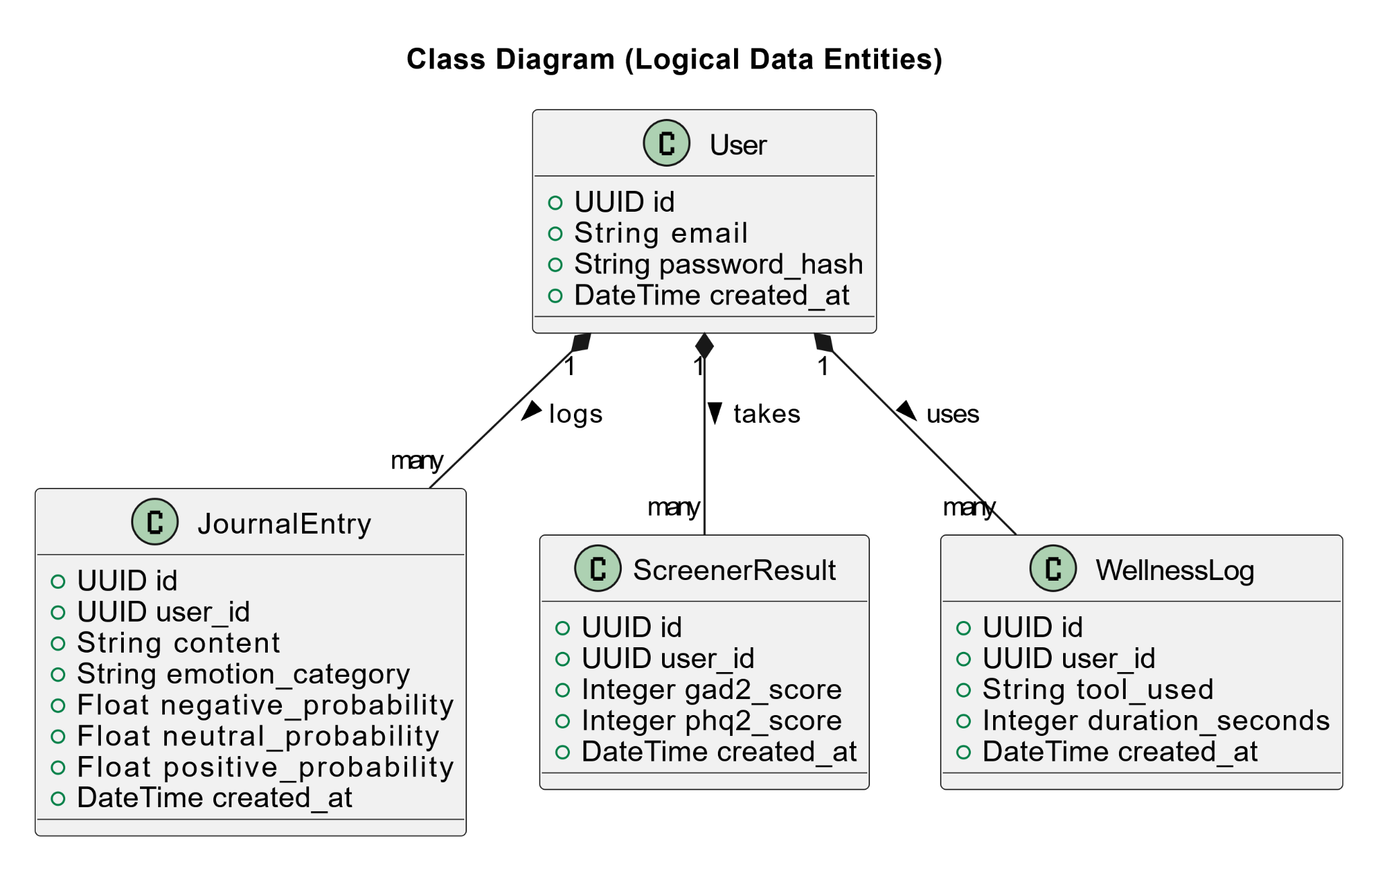

4. Scrum Board — Sprint 2
The table below represents the Trello Scrum Board state at the end of Sprint 2, organized into three columns: To Do, In Progress, Testing, Leftover and Done.

Snapshot 1 — Trello board showing the initial Sprint 2 backlog in the "To Do" column.
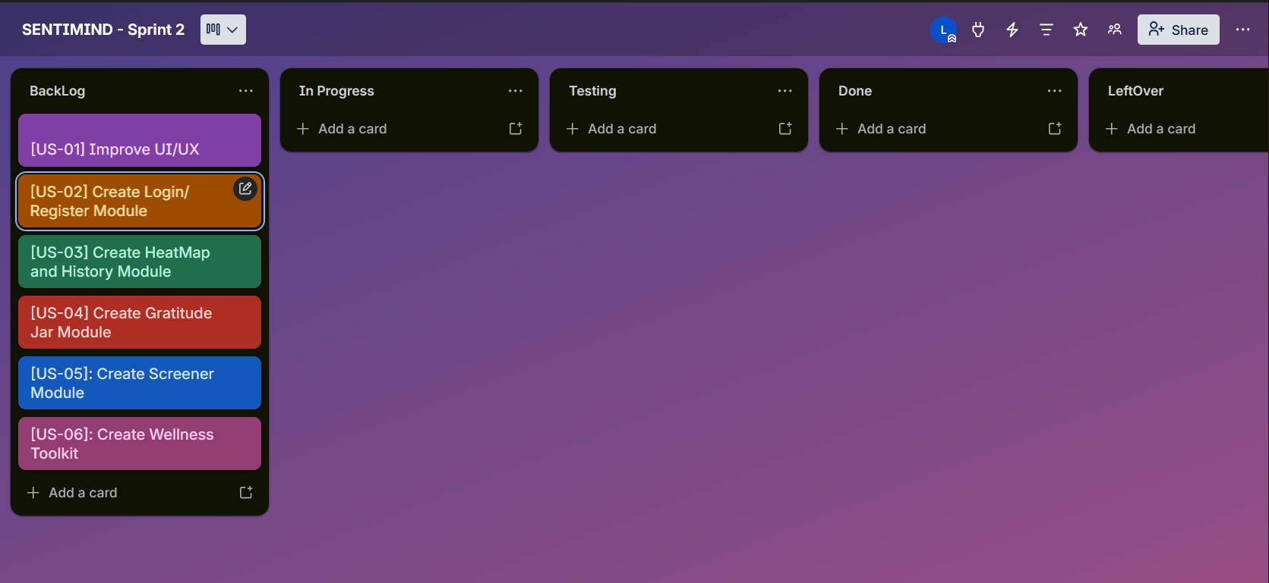

Snapshot 2 — Trello board mid-sprint, with tasks moved to "In Progress" and "Done".
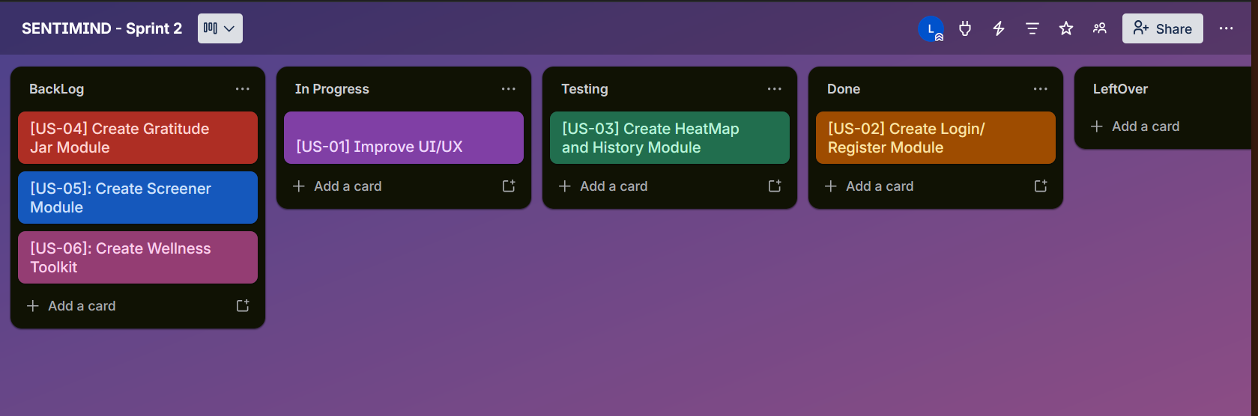

Snapshot 3 — Trello board at end of Sprint 1 showing all completed tasks.
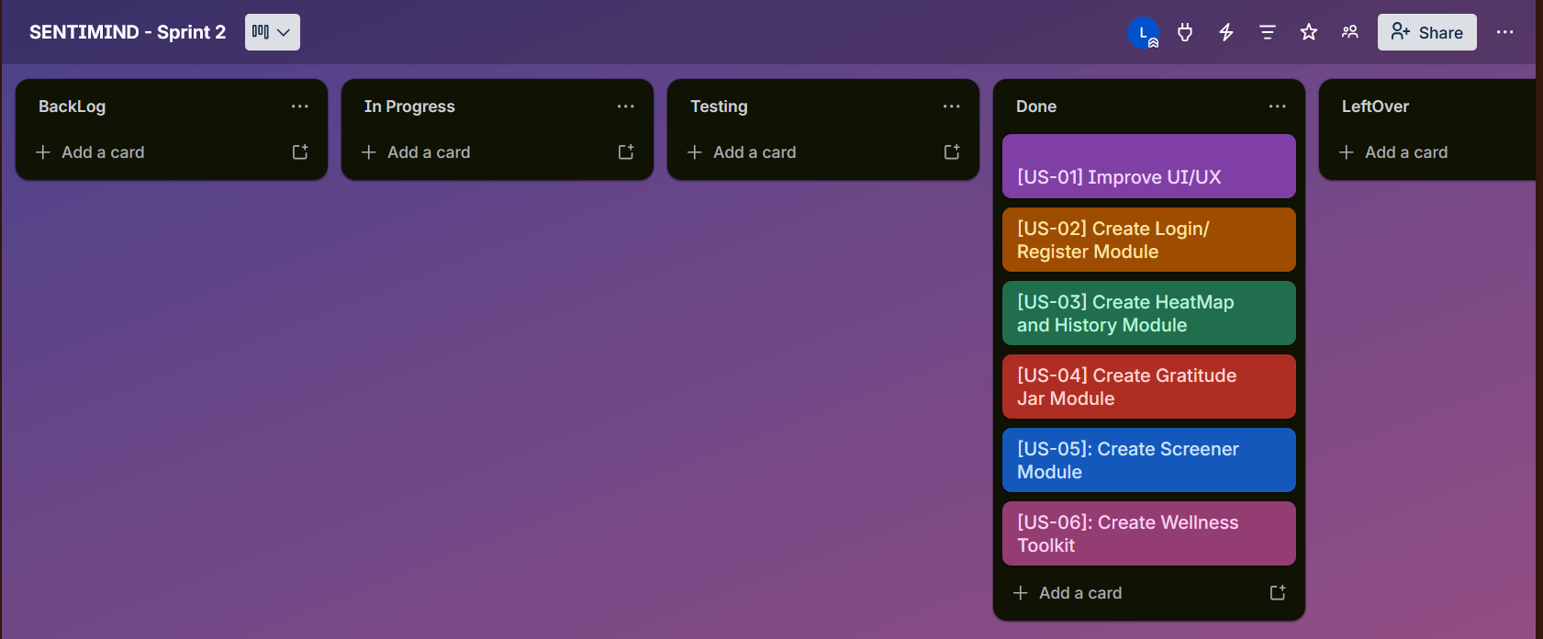

7. Work Division
SentiMind is a solo final-year project. All tasks were designed, implemented, tested, and documented by Abdullah Mushtaq (23L-0892). The table below provides the full breakdown by subsystem for assessment transparency.
Subsystem | Owner
Improving UI/UX | Abdullah Mushtaq (23L-0892)
Login Module | Abdullah Mushtaq (23L-0892)
History and Heatmap Module | Abdullah Mushtaq (23L-0892)
Wellness Toolkit | Abdullah Mushtaq (23L-0892)
Clinic Screener Module | Abdullah Mushtaq (23L-0892)
Documentation & Scrum Board | Abdullah Mushtaq (23L-0892)

— End of Deliverable 2 / Sprint 2 —

